CMPE 100 Lab Report 1

Leonid Shuster

Lab Section 1C

4/12/19

**Description:**

The purpose of this lab was to become more familiar with using the oscilloscope by uploading a bitstream file to the Basys3 board and measuring and analyzing the voltages across two pins on the board to display two waveforms. We also sought to become more familiar with the Basys3 board and Vivado Design Tools by creating our own design and downloading it to the Basys3 board and interacting with the switches and LEDs on the board. The lab consisted of the following two parts.

**Part One: Using the Oscilloscope**

In this part of the lab we learned how to use various features of the oscilloscope to manipulate the waveforms produced. In particular, we learned how to change the vertical scale and horizontal scale, as well as how to synchronize the samples with an event in the signal. We also learned how to upload a bitstream file to the Basys3 board. We attached source 1 and source 2 of the oscilloscope to pins JA-1, JA-3, and ground of the JA connector of the board, and set switch 0 on the board to be high. We then uploaded a sample bitstream to the board, and analyzed the waveforms that appeared on the oscilloscope. Specifically, we observed the horizontal and vertical graduations, sweep rate, vertical gain, and frequencies of the two waveforms. The results of the measurements are shown in Appendix A, and are as follows:

|  | **Source 1** | **Source 2** |
| --- | --- | --- |
| **Horizontal graduation** | 20 microseconds, 248.2 microseconds time delay | 20 microseconds, 248.2 microseconds time delay |
| **Vertical graduation** | 2 V | 2 V |
| **Sweep rate** | 10 microseconds | 4.8 microseconds |
| **Vertical gain** | 3.3 V | 3.3 V |
| **Frequency** | 6.1035 kHz | 97.66 kHz |

According to our results, source 1 (source connected to JA-1) had a higher sweep rate and a lower frequency. Source 2, on the other hand, had a lower sweep rate and a higher frequency. One oddity that was discovered was the small jumps in voltages of the scope connected to pin JA-1. I believe that the cause of these jumps is that there is some leftover voltage in the wires and pins everytime the voltage changes from low to high and vice versa.

**Part Two: Entering a simple schematic**

In the next part of the lab, we learned how to use Vivado Design Tools to create our own design and upload it to the Basys3 board. We were tasked with mapping the NOT of pushbutton BTNC to LED LD0, the AND of switch SW0 and SW1 to LED LD1, the OR of switch SW0 and SW1 to LED LD2, and the XOR of switches SW0, SW1, and SW2 to LED LD3. In other words, the following truth tables should have held true:

| LD0 = ~BTNC   | **BTNC** | **LD0** | | --- | --- | | 0 | 1 | | 1 | 0 | | LD1 = SW0 & SW1   | **SW0** | **SW1** | **LD1** | | --- | --- | --- | | 0 | 0 | 0 | | 0 | 1 | 0 | | 1 | 0 | 0 | | 1 | 1 | 1 | | LD2 = SW0 ^ SW1   | **SW0** | **SW1** | **LD2** | | --- | --- | --- | | 0 | 0 | 0 | | 0 | 1 | 1 | | 1 | 0 | 1 | | 1 | 1 | 1 | | LD3 = SW0 ^ SW1 ^ SW2   | **SW0** | **SW1** | **SW2** | **LD3** | | --- | --- | --- | --- | | 0 | 0 | 0 | 0 | | 0 | 0 | 1 | 1 | | 0 | 1 | 0 | 1 | | 0 | 1 | 1 | 0 | | 1 | 0 | 0 | 1 | | 1 | 0 | 1 | 0 | | 1 | 1 | 0 | 0 | | 1 | 1 | 1 | 1 | |
| --- | --- | --- | --- | --- | --- | --- | --- | --- | --- | --- | --- | --- | --- | --- | --- | --- | --- | --- | --- | --- | --- | --- | --- | --- | --- | --- | --- | --- | --- | --- | --- | --- | --- | --- | --- | --- | --- | --- | --- | --- | --- | --- | --- | --- | --- | --- | --- | --- | --- | --- | --- | --- | --- | --- | --- | --- | --- | --- | --- | --- | --- | --- | --- | --- | --- | --- | --- | --- | --- | --- | --- | --- | --- | --- | --- |

After creating a project and adding and editing the constraint file to route the outputs to the board, I implemented the design in a single file called logic_gates and used Vivado Design Tools to create a schematic (also found in Appendix B):

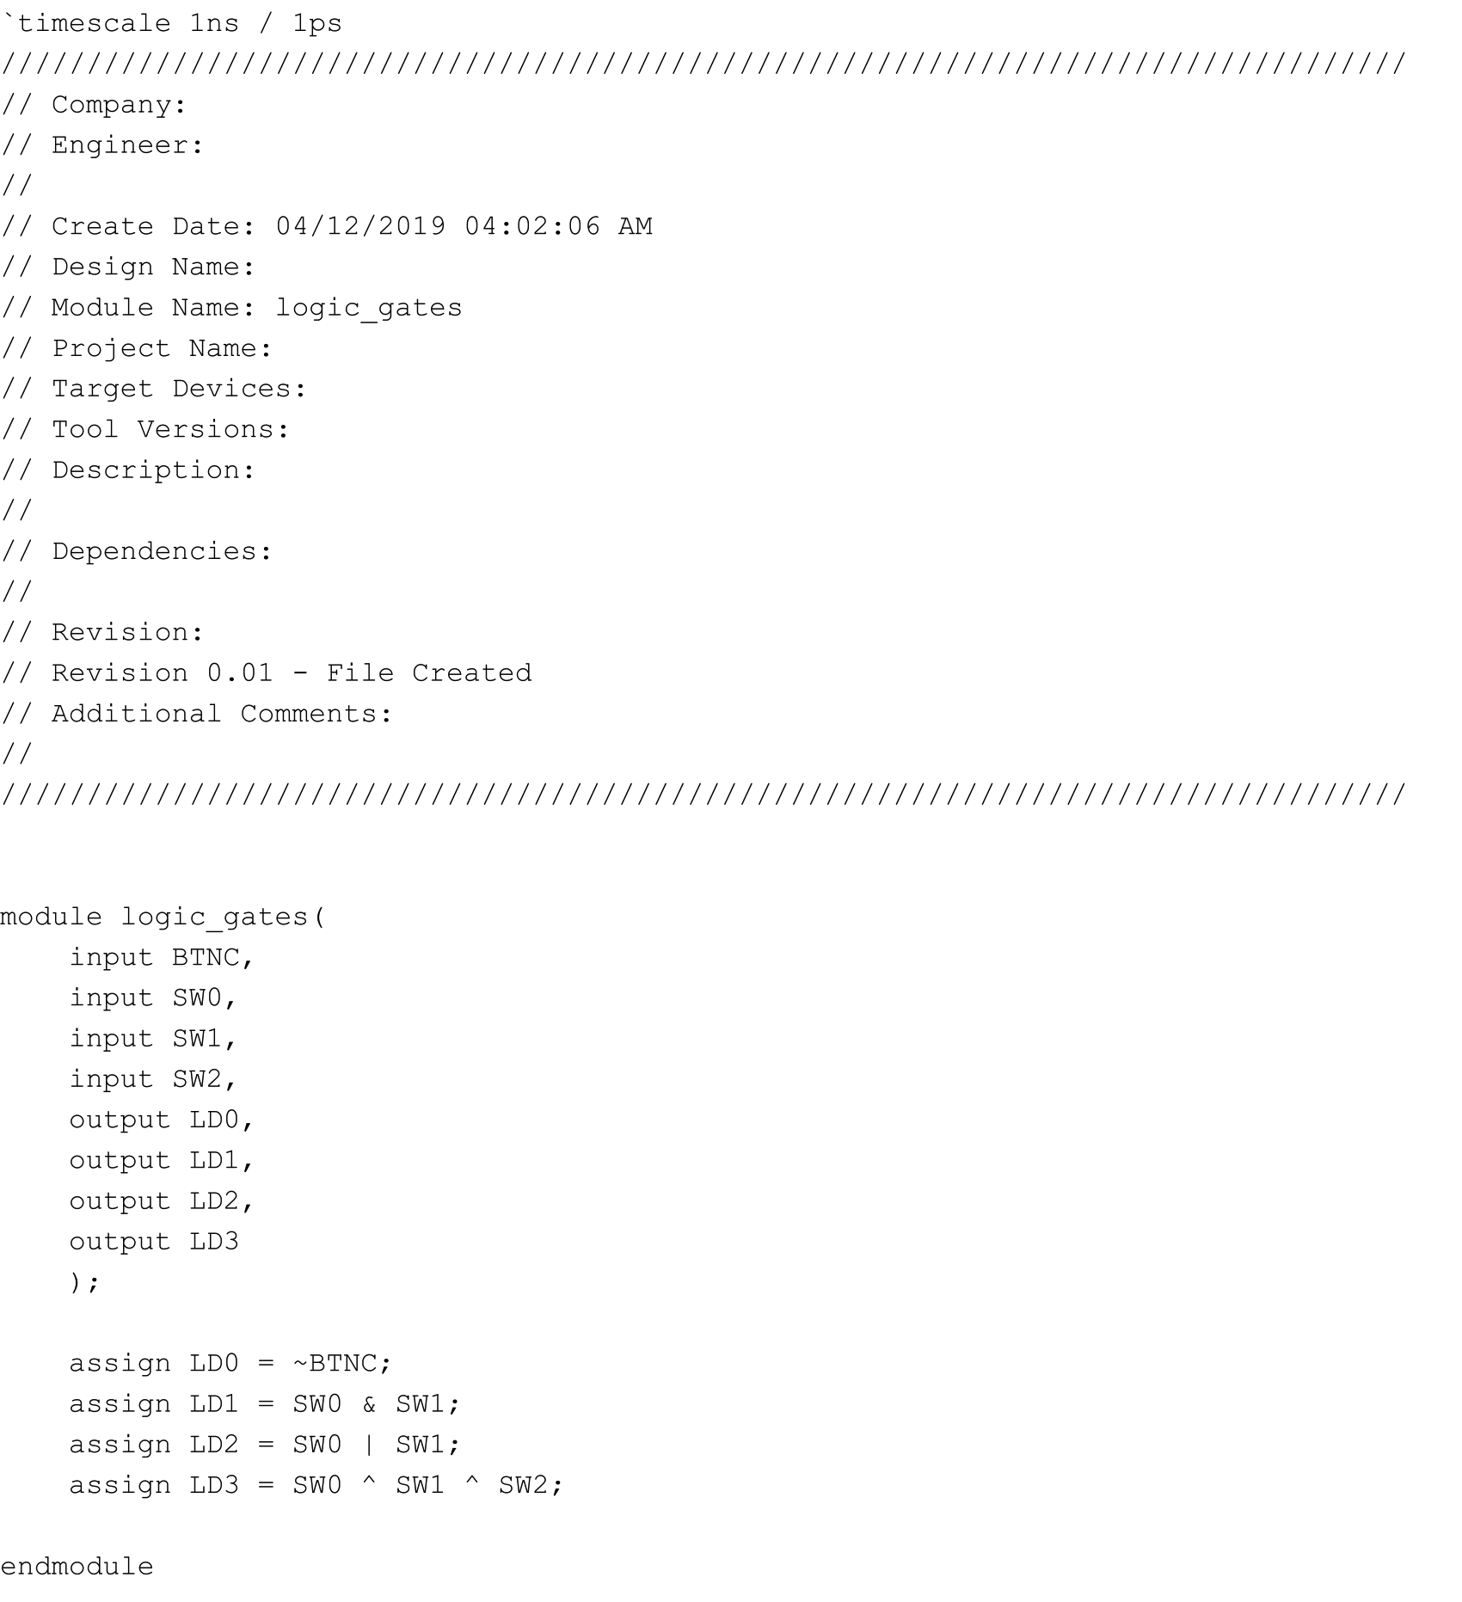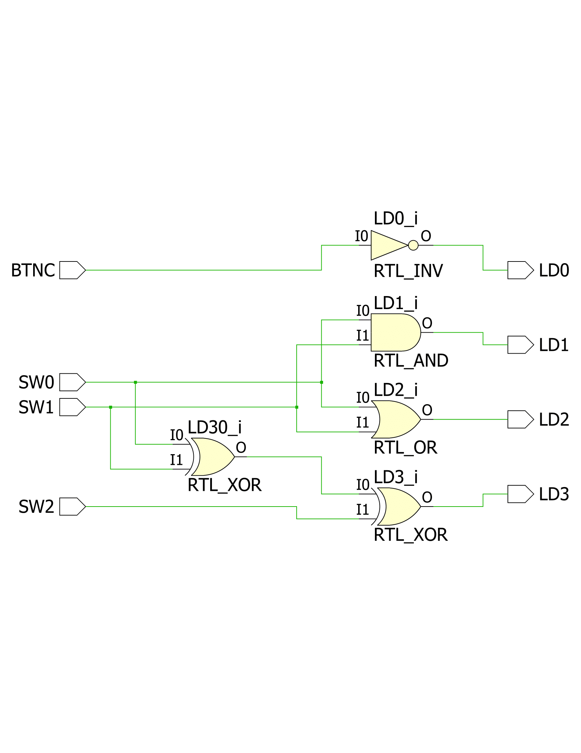

logic_gates.v logic_gates schematic

I then generated a bitstream file, downloaded it onto the Basys3, and did a series of tests on BTNC, SW0, SW1, and SW2 and indeed saw that the logic worked as it should have.

**Conclusion:**

In the first part of the lab, we connected the oscilloscope to two pins on the Basys3 board, and measured and analyzed the voltages across the two pins over time. In the second part of the lab, we got to create our own design, and implemented several logic gates and proved that they worked after downloading our design onto the board and interacting with the switches and seeing our results through the LEDs. After getting a deeper understanding of how an oscilloscope and Vivado Design Tools work, I now have the tools to create more complex designs.

**Appendix**

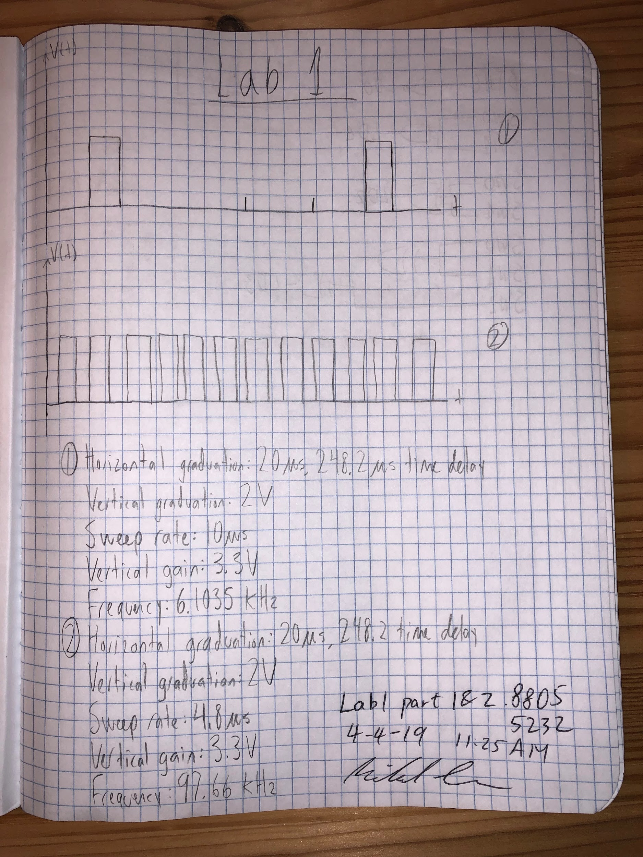

Appendix A

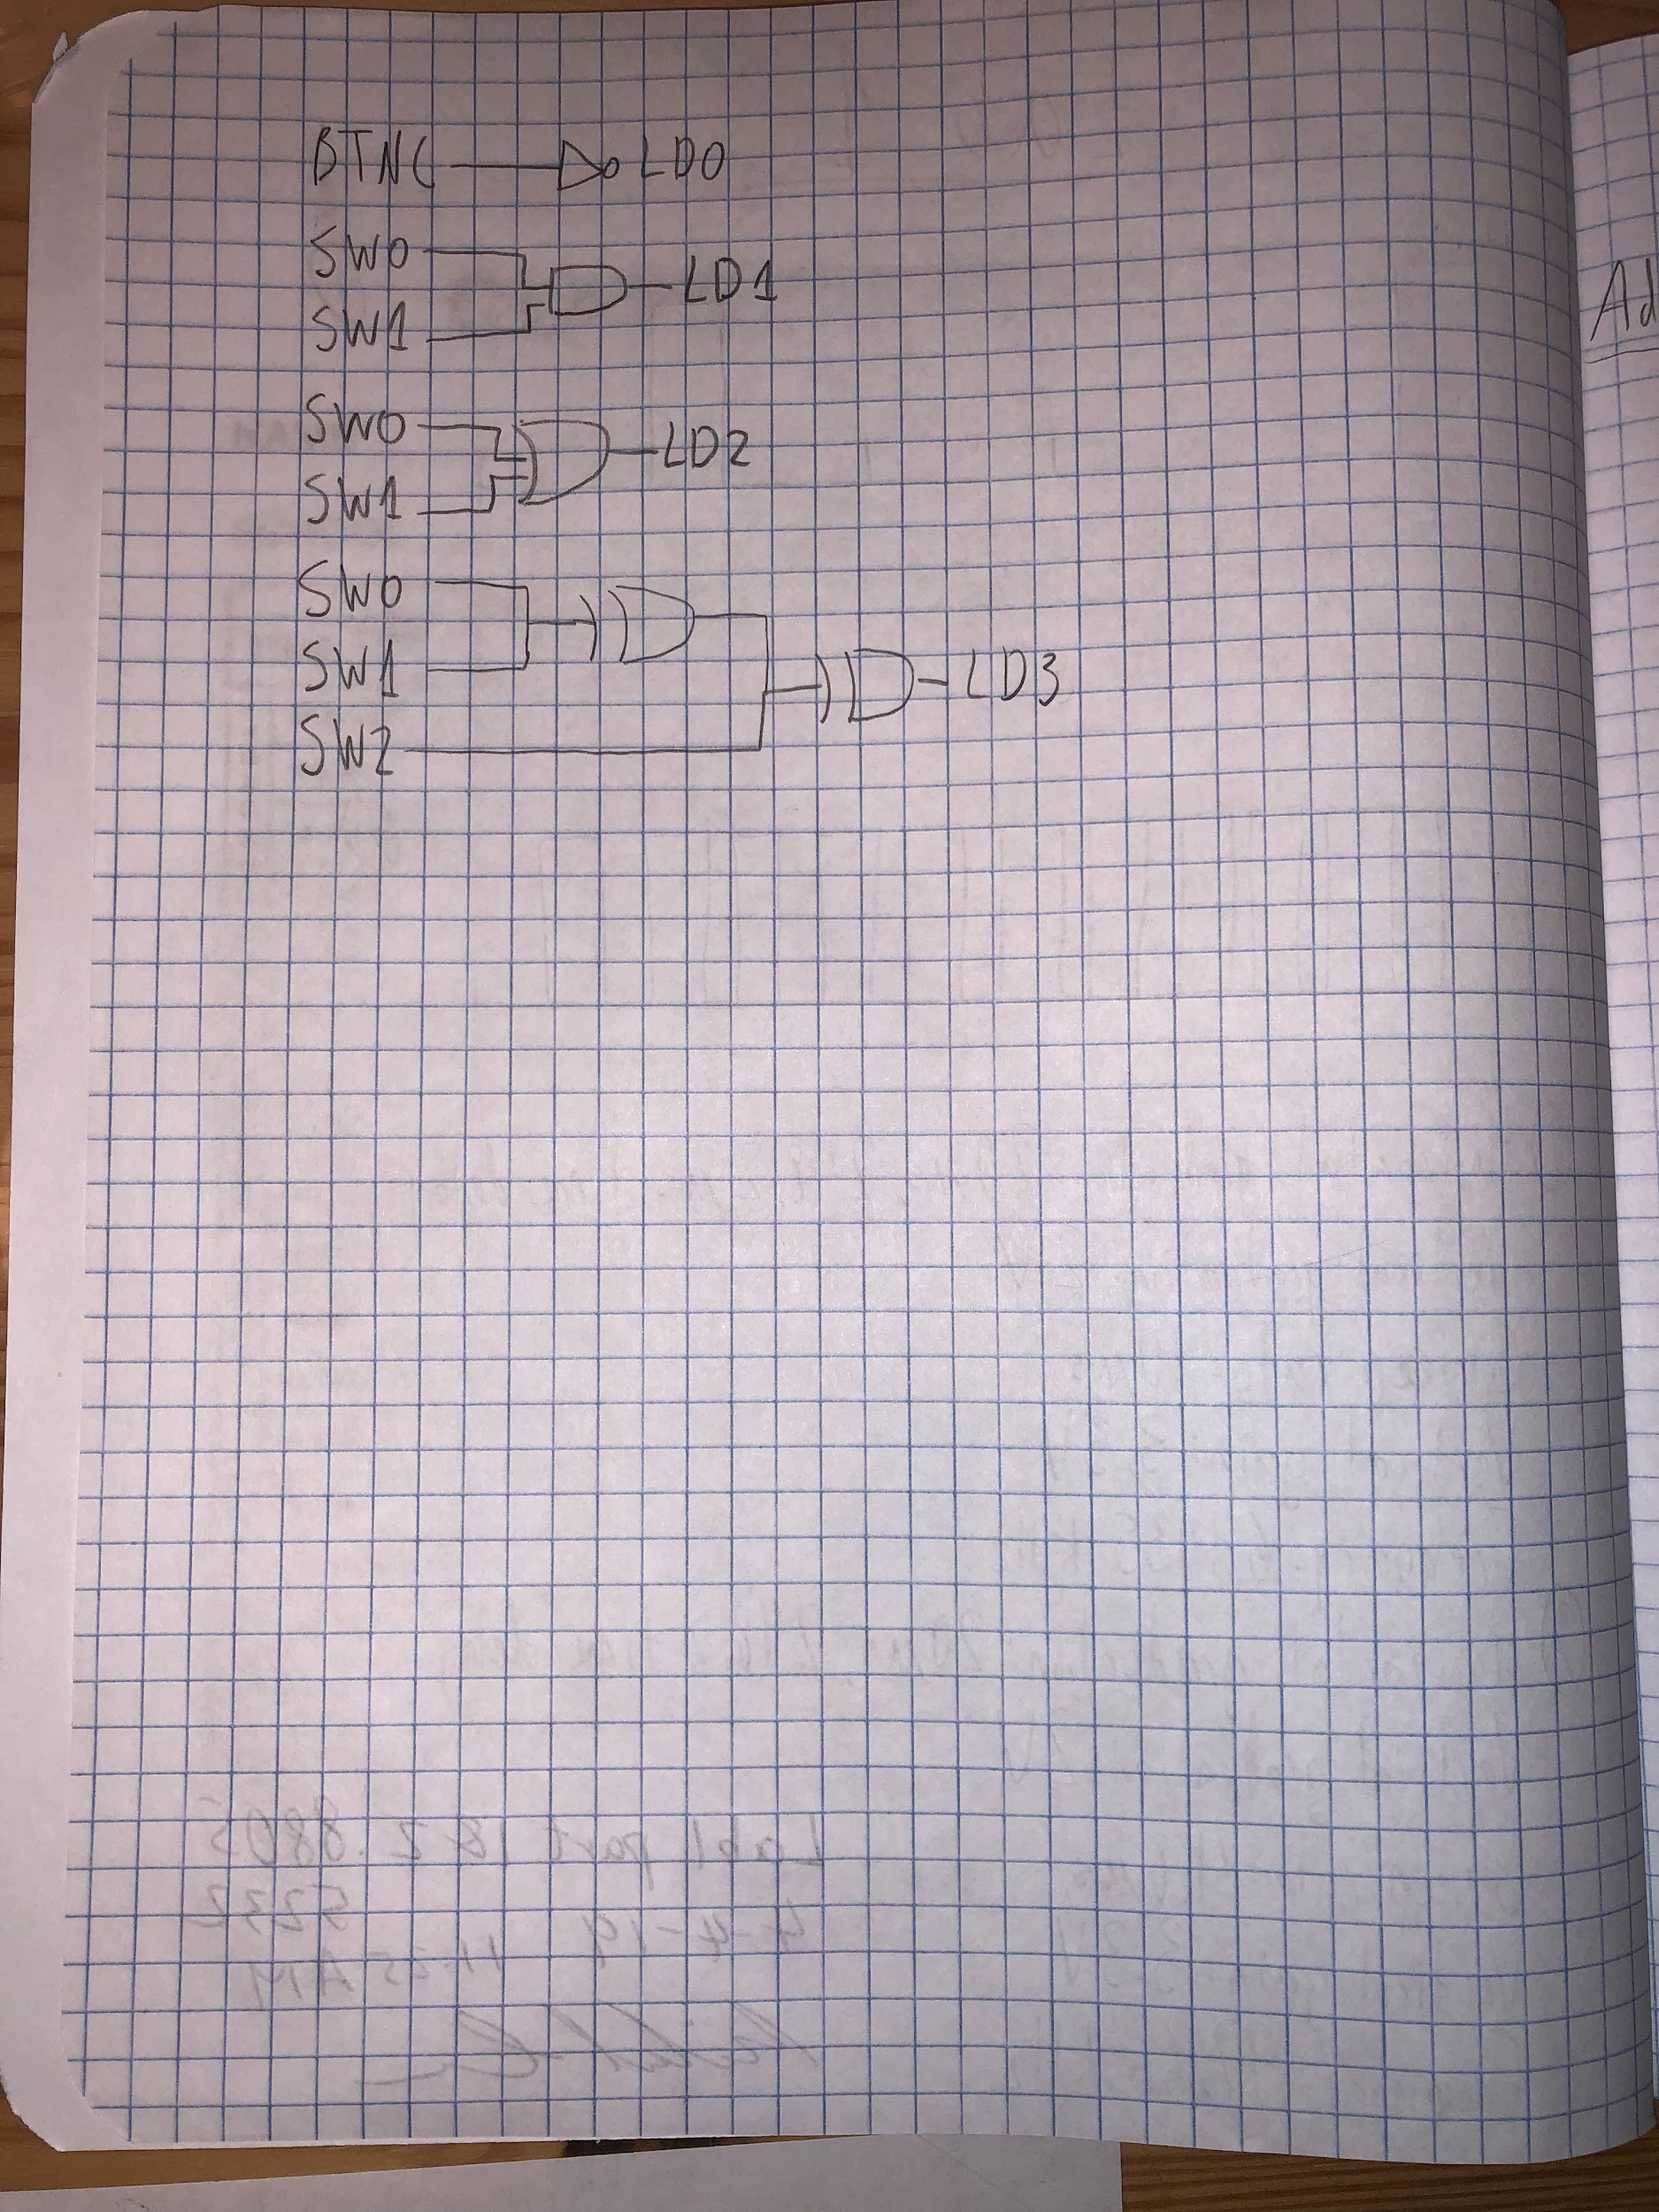

Appendix B